<https://mystockmarketbasics.com/make-personal-investment-plan-strategy/>

**Make Investing about YOU with a Personal Investment Plan**

*Posted on***AUGUST 7, 2017***Written by*[**JOSEPH HOGUE, CFA**](https://mystockmarketbasics.com/author/finance101/)[**3 COMMENTS**](https://mystockmarketbasics.com/make-personal-investment-plan-strategy/#comments)

**Make an investing strategy that’s right for YOUR needs with a personal investment plan**

**Want to know the worst mistake in investing, the mistake almost all individual investors make?**

It’s a mistake that causes the average investor to lose money and underperform the stock market by a wide margin.

Even after the worst stock market crash in nearly a century, stocks managed to return an annualized 7.4% over the ten years to 2013. Even bonds did pretty well as ever lower interest rates helped corporate debt to an annual return of 4.6% over the period.

Average them out and an investor with a 50/50 portfolio should have made about 6% a year over the decade.

You probably won’t be dining on caviar every night on 6% but it’s a respectable investment return and all most people need to reach their dreams of financial freedom.

*Unfortunately, actual investor returns fall far short of these investment averages.*

[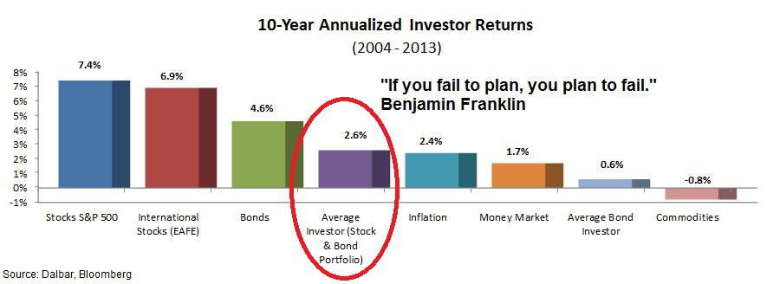](https://mystockmarketbasics.com/wp-content/uploads/2016/03/Personal-Investment-Plan-Average-Investor-Returns.jpg)

Personal Investment Planning and Why Most Investors Fail

The average investor with a stock & bond portfolio earned just 2.6% a year over the decade to 2013. That’s just 0.2% over the average rate of inflation! At that rate, it would take 168 years to accumulate a $1 million portfolio by saving $5,000 a year.

*Why do individual investors do so poorly investing in their financial future?*

**Time to Make Investing Personal**

The problem isn’t that investors are picking the wrong stocks. It’s not that stock market crashes keep wiping out their hard-earned gains.

The problem is the bad investment behaviors people make when they aren’t guided by a personal investment plan.

A personal investment plan, also called an investor policy statement (IPS), is one of the most important concepts in personal finance. It is also one of the least understood and most often neglected.

A personal investment plan is your road map for where you want to go with your finances and how to get there. It helps you understand what kind of return you need on your investments and how much risk you are willing to accept. Your personal investment plan also helps to understand your own specific constraints like taxes, time, legal restraints, spending needs and unique circumstances.

Without a personal investment plan, most people buy into the current investment fad only to get nervous and sell when the market crashes. They end up paying enormous fees from frequent trading and penalties for early withdrawals. They lose more money to taxes than they should and just generally under-perform the market.

Without a personal investment plan, you risk forever being lost with your money and too bull-headed to ask for directions.

**What is a Personal Investment Plan?**

[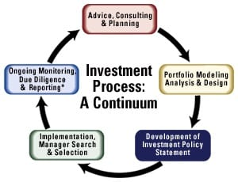](https://mystockmarketbasics.com/wp-content/uploads/2016/03/Personal-Investment-Plan-Process.jpg)

The Personal Investment Planning Process

A personal investment plan is a formal and personalized document detailing your personal finance needs and constraints. It is a critical step in the investment process and a requirement for most financial advisors.

Creating a plan for investing, given your specific goals and needs, will give you the confidence that you’ve picked the right investments and can ride out the ups-and-downs of the market. Your plan helps to stay the course when markets stumble and helps keep your investments aligned as your goals and return needs change.

Without an investment plan, you’re just throwing darts and hoping to get lucky with a few stocks. Without a plan, the only ones that get rich are the brokers and advisors.

Let’s look briefly at the process of putting a plan together and then we’ll go through a personal investment plan example.

A personal investment plan starts off by looking at your current savings and how much you need to meet spending needs in the future. This is going to help find what kind of return you need on your investments to reach your goal of financial freedom.

With your return in mind, the plan also looks at your investment risk tolerance. This is not just your willingness to tolerate the ups-and-downs of the market without too much stress but also your ability to handle the risk and still meet your goals.

Finding the return you need to meet your goals and guiding your investments according to risk is hugely important but almost entirely neglected by investors. Simply chasing the highest return possible leads investors to invest everything in stocks. They trade in and out of any stock they hear on TV and pay a fortune in fees.

Their investments aren’t grounded in any plan so, when stock prices start to crumble, investors panic-sell and end up losing money.

Beyond your own need for return and tolerance for risk, your personal investment plan factors in other investment constraints specific to your circumstances. With a plan in place, you’ll have a better idea of the investments you need to meet your need for return at the lowest risk.

A personal investment plan also helps keep you on your path to financial future. It helps you measure your progress to your ultimate goals and keep from trading in and out of investments. Besides the end result of outlining your path to financial freedom, a personal investment plan is also an educational tool.

Actually thinking through the parts of the plan, you’ll get a better understanding of yourself as an investor. You’ll understand an appropriate [stock market investment strategy](https://mystockmarketbasics.com/stock-picking-strategies-work/) and won’t blindly follow what you hear on TV or in the financial media.

**Setting Investing Goals in your Personal Investment Plan**

Your personal investment plan starts with comparing your current investments with what you need in the future and the return you’ll need to get there. It’s easiest to work backwards from your financial goals to estimate the investment return you’ll need.

* Estimate the living expenses you’ll have in retirement. The rule of thumb is 80% of your current spending but this can be way off depending on how much traveling you want to do and other expenses.
* Are there any other large expenses you need to plan for like tuition or a gift?
* How many years until you plan on full-retirement and living off of your investments
* How much do you estimate you can save each year until retirement?
* What is the current value of your total wealth, not including primary residence

There’s two ways to find the return you need for your investment plan, with a financial calculator or [using one of the investment calculators](https://mystockmarketbasics.com/investing-calculators/) on this site.

If you decide to use a financial calculator, you’ll use the Time Value of Money function. That means putting in the amount you need at retirement, years left to retirement, how much you plan on saving each year and the present value of your portfolio. The calculator will then estimate the return you’ll need to reach your future value goal.

Example: I need a portfolio of $1,100,000 by the time I am 67 to live comfortably. That includes helping to pay for my son’s college expenses and some travel plans during the first few years of retirement. I am 38 years old now so I have 29 years left to retirement. My total wealth of $240,000 includes two rental properties and a portfolio of stocks, bonds and other investments. I am able to save and invest $5,500 each year until retirement.

Future Value = $1,100,000  
Payments (annual saving) = $5,500  
Time to retirement (N) = 29  
Present Value = $240,000  
**Return needed = 4.2%**

A return of 4.2% is easily achievable with even a low risk portfolio of investments. Imagine if I didn’t know that I only needed a 4.2% annual return to meet my financial goals. I might be chasing higher returns in stocks or other risky investments, risking the possibility of a market crash and not meeting my goal. Knowing my need for return is so low, I can either invest very safely and secure my financial future or adjust my retirement plans slightly higher and invest for a little higher return.

If you’re familiar with financial calculators, it’s an easy enough process. If not, you can also use trial-and-error on this [retirement investment calculator](https://mystockmarketbasics.com/investing-calculators/retirement-income-calculator/). These require putting in all the information above and the calculator will tell you how much you’ll have saved by retirement.

That means you’ll have to play around with the numbers, changing investment return and contributions to reach your financial goal. The idea is to find a contribution amount that you can afford each month and a return between 4% to 7% on an annual basis.

If you have a employer-sponsored 401K plan at work, you can [use this 401K calculator](https://mystockmarketbasics.com/investing-calculators/401k-calculator/) to estimate your retirement income.

That return between 4% to 7% is reasonable without taking on too much investment risk. If the calculator says you need a higher return, try increasing the amount you contribute each month or adding a few years to retirement. If it says you need a return lower than 4% then you can probably aim for a higher goal.

[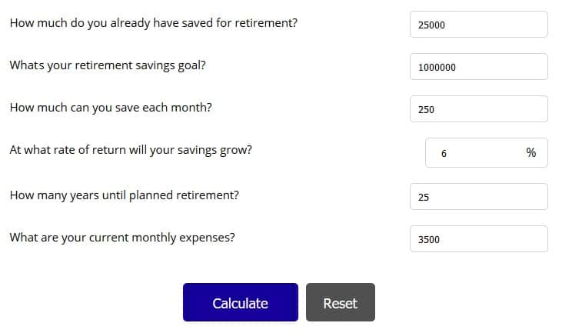](https://mystockmarketbasics.com/wp-content/uploads/2018/01/retirement-income-calculator-example.jpg)

Use this Investment Calculator to Customize an Investing Plan

After your required return is found, you need to consider your tolerance for investment risk. This is broken into two components, your ability and willingness to tolerate risk.

* **Ability to tolerate risk** depends on the size of your current portfolio and the importance of your financial goals. If some of your financial goals are not critical, i.e. buying a vacation home, then you are able to tolerate a little more risk compared to someone that absolutely must meet their goals. If you already have a sizeable investment portfolio, then you may be able to tolerate a little more risk and still meet your financial goals.
* **Willingness to tolerate risk** is much more an emotional preference. Are you comfortable with large swings in your portfolio value or do you get nervous if the stock market tumbles? Are you a gambler or someone that prefers the insured and certain path? Knowing your willingness to tolerate risk is all about being able to sleep at night, no matter what the market does.

I put together a 10-point [questionnaire to determine your investment risk tolerance](https://mystockmarketbasics.com/find-investment-risk-tolerance/) in a prior post. It covers ideas within your ability and willingness to tolerate risk and is helpful in finding your own tolerance.

If you have a low tolerance for risk but need a high annual return to meet your financial goals, you may be in trouble. Higher returns generally mean higher risk in investing. Few investments offer annual returns over 10% over the long-term and it’s not without significant risk. Investors with lower risk tolerance that push for higher returns in these investments usually end up missing the mark because they sell at the first sign of volatility.

The graphic below places the most common asset classes by general volatility. Treasury bonds guaranteed by the United States government are considered the risk-free investment but yield very little after inflation. Investments in commodities and stock options hold the potential for high returns but also carry more risk than most investors are able to handle.

[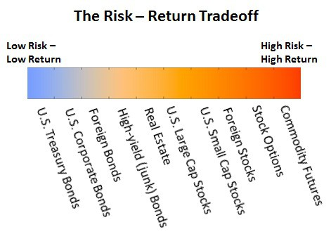](https://mystockmarketbasics.com/wp-content/uploads/2016/03/Personal-Investment-Plan-risk.jpg)

Risk and Return Tradeoff in Different Investments

A diversified portfolio means holding a mix of assets from several classes; i.e. holding bonds, real estate, and stocks from the U.S. and abroad. Holding a mix of these investments can actually help lower the overall risk in your portfolio because each investment class will react differently to market conditions.

The proportion you hold in each asset class is why you need your personal investment plan. If your tolerance for risk is low and you only need a moderate annual return, you will want to hold more bonds in your portfolio and less stock. If you have a higher risk tolerance and need stronger returns, you will need to hold more stocks and a smaller proportion of bonds.

*A recent survey by Vanguard found that two-in-three investors did not own enough bond investments in their portfolio. That leaves them dangerously at risk of a stock market crash and missing their investment goals.*

**Constraints on your Personal Investment Planning**

While risk and return are the most important pieces of your personal investment plan, there are five other factors that will help you think about your own circumstances and put everything in context. These are liquidity, time horizon, taxes, legal & regulatory environment and unique circumstances.

**Liquidity** is the ability to sell or convert investments to cash quickly to meet regular expenses or for emergency needs. While you may not be retiring for many more years, you may need cash soon to buy a home or pay for tuition. Certain investments like stocks are easily sold and generally do not involve high transaction fees. Other investments like real estate might take a while to sell and will cost more in fees. If you do not need money to help pay normal living expenses and you have set up an emergency savings fund, you probably do not need a high level of liquidity in your investments.

**Time horizon** is the measure of how much time you have left to major spending decisions like tuition, home purchase or retirement. The idea is that, your investment risk should decrease as you get closer to needing your money.

One of the biggest mistake investors make is putting their money in high-risk stocks even though they need that money within a couple of years. Any money you are going to need within the next year or two should be set aside in very safe investments like bonds and money market funds.

I know it sucks to sit there watching the down-payment on a new home earn less than a percent but imagine having that money in stocks when a crash occurs. As confident as you are that the market will continue higher, you absolutely must protect the money you are going to need near-term.

More than a few people have had to put off retirement because they were fully-invested in stocks when the market lost half its value to March 2009. Had they shifted their short-term needs to the safety of bonds, they would be sipping Pina Coladas on a sandy beach by now.

Time horizons longer than 15 years are generally considered long-term and can bear more investment risk. If you are within three years of a major spending need, your time horizon is considered fairly short and you need to adjust your investment risk.

**Taxes** are a tough subject to generalize because rates vary so much by individual and by location. Taxes can hit your portfolio in the form of capital gains when you sell investments or as income taxes on dividends or distributions. About the only general advice that can be given on taxes is to take advantage of every form of credit or deduction.

* Max out the match on your company’s 401k plan and contribute up to the limit into an individual retirement account (IRA). The downside to not being able to withdraw your money until you reach 59 ½ is more than offset by the tax advantages. Your company is giving you FREE money with its match, that’s the best investment return you’ll ever earn. You need to save for retirement anyway, you might as well let the government help you by giving you a tax break.
* Invest a portion of your portfolio in tax-advantaged assets like real estate investment trusts (REITs) and master limited partnerships (MLPs). These special corporate structures do not pay income taxes if they pass income through to investors. That sets them up for higher returns than other taxable corporations. One of the most promising [new ways to invest in real estate](https://mystockmarketbasics.com/real-estate-crowdfunding-good-investment/) is through crowdfunding platforms like [RealtyShares](https://mystockmarketbasics.com/realtyshares" \t "_blank). The site gives you the opportunity to invest in real estate projects with as little as $5,000 and instant diversification. Returns are in the double-digits and higher without all the hassle of managing your own properties.
* Higher income investors may want to consider holding municipal bonds since the interest payments are generally tax-free.
* Losses on some investments may be used to offset other investment gains through tax-loss harvesting in a given year. It’s generally best to buy-and-hold your investments even through temporary losses but tax-loss harvesting might offer a good opportunity to lower current taxes.

The **legal and regulatory constraints** in your personal investment plan will vary depending on where you live. These will affect how you pass money to heirs, property rights and how your income or gains is taxed.

**Unique circumstances** in your personal investment plan are a sort of catch-all for other constraints on your investments. These might include personal preferences for types of investments or restrictions on investments.

* Some investors do not want to hold stock in companies within gambling, tobacco or fossil fuel industries
* You may be restricted from selling company stock or other investments

**A Personal Investment Plan Example**

Let’s look at an example personal investment plan with a hypothetical investor. This is just an example but should give you some ideas on how the different factors are used to help guide your plan.

For more detail on how to find your investor type and how to invest for every decade of your life, check out this [**series on life-long investing**](https://mystockmarketbasics.com/life-long-investing-plan/).

Our example investor is 40 years old, married and has a household income of $55,000 annually. She currently has $40,000 saved for retirement and estimates she and her husband will need about $40,000 a year when they plan on retiring in 27 years.

* She estimated the $40,000 need from their current expenses of $44,500 after taxes. She multiplied their current expenses by 90% (times 0.90) to get a rough estimate of retirement expenses.
* Social Security provides around $15,000 on average after taxes but she doesn’t want to depend on that in retirement.
* She is able to save about 10% of their income or $390 a month.
* Using a financial calculator (27 years to retirement, $40,000 saved, annual contributions of $4,675) she finds that a 6% return will produce a portfolio of $490,718 by retirement.

That’s enough to provide for $20,000 each year in retirement if she withdraws 4% a year. That means she and her husband only need to rely on Social Security for $10,000 each to meet their expenses.

Taking an investment risk tolerance questionnaire, she finds she has about average tolerance for risk. They still have nearly three decades to retirement and stable jobs so they don’t have to worry about income loss. The 6% return she needs on an annual basis is low enough that she can invest a large part of her wealth in bonds and other safe assets.

Putting together your own personal investment plan can be quite a challenge. Even if you do not plan on working with a financial advisor over the long-term, you might consider paying an advisor to help you put your plan together. You can still do all the investing yourself but the advisor will be able to help you understand each part of your personal investment plan and how it relates to different investments. Whatever you decide, do not neglect writing up a personal investment plan or procrastinate it simply because it will take some effort. Having a plan is one of your first steps to financial freedom and getting on the path to meeting your financial goals.

<https://mystockmarketbasics.com/find-investment-risk-tolerance/>

**How to Find Your Investment Risk Tolerance**

*Posted on***MARCH 21, 2016***Written by*[**JOSEPH HOGUE, CFA**](https://mystockmarketbasics.com/author/finance101/)[**LEAVE A COMMENT**](https://mystockmarketbasics.com/find-investment-risk-tolerance/#respond)

**Investing without understanding your investment risk tolerance is a sure way to miss your financial goals and create sleepless nights.**

Investment risk tolerance is one of the most important but overlooked concepts in investing. Investors eager to reach their financial goals for retirement or that dream vacation read through a few websites about stocks and bonds before putting their money in some popular funds or products.

Then the sleepless nights come as stocks turn skittish or bonds struggle along, barely earning a rate of return. What appeared like a diversified portfolio now consumes the investor’s thoughts and they end up making poor investment decisions like panic-selling.

The problem is that; while you may have bought a good mix of stocks, bonds and other assets, the portfolio wasn’t created for your own ability to handle risk. Your investment risk tolerance is your ability and willingness to accept fluctuations in your investments, and to do it without losing sleep. Risk is one of the key parts of investing.

It does you no good to jump into a set of investments if the constant ups-and-downs are going to drive you crazy. You’ll end up spending all your investment gains on medicine for high-blood pressure and nerves. On the other-hand, investing in super safe assets will make higher-risk investors impatient and may not help them reach their financial goals.

Figuring out your own investment risk tolerance, and the most suitable investments, is actually fairly easy. There are quite a few handy tools on the web and we’ll go through a list of questions below. It’s the first step in creating your Investor Policy Statement (IPS), a personal investment strategy that everyone needs before investing.

**Questions to Ask to Decide Your Investment Risk Tolerance**

Determining your investment risk tolerance is usually done through a set of questions, both data and hypothetical. Think about each and how it applies to your own risk tolerance. Each question is associated with a point scale. Give yourself one point for the first answer, two points for the second, and so on.

**1) When do you expect to be using the money from your investments?**

* Less than a year
* 1-3 years
* 3-10 years
* After more than 10 years

If you are going to need your money in less than a few years, your investment risk tolerance is going to be very low. You cannot afford for the stock market to take a nose dive and wait for the recovery. If you won’t need the money for decades, you can accept the ups and downs that come every 3-5 years. *(Score from one to four points)*

**2) How important is it that you reach this particular financial goal?**

* Couldn’t live without it
* I’ll get by but it will be difficult
* No significant change in lifestyle but I will be disappointed

The importance of reaching a particular financial goal is something most don’t think about with their investments. They lump investments for retirement and education in with their vacation money and everything else. You will be able to tolerate a little more risk, and potentially see higher returns, with less important financial goals. *(Score from one to three points)*

**3) How long will you be spending money from the investment?**

* I will spend it all immediately
* It will probably be spent between a year and five years
* I will be spending the money down over a long-term, greater than 10 years

If you are going to be needing all or most of the money at a specific date, or over a short period, then you will have less tolerance for risk. The tuition expenses won’t wait a few years for the market to recover. On the other hand, if you can withdraw money gradually and let the rest accumulate, you may be able to handle a little more risk. *(Score from one to three points)*

**4) How often do you sell your investments after buying them?**

* Usually within one or two years
* After three to five years
* I hold on to investments for a very long time, greater than eight or ten years

Notice there is no choice for less than a year, that’s not investing but gambling on the short-term craziness of the market. Active investors, those buying and selling more frequently, are usually able to handle a little more risk in their investments without losing much sleep. *(Score from one to three points)*

**5) If a stock I owned lost 30% of its value over the course of a few months, as happened broadly in 2008, I would most likely…**

* Sell all of the investment
* Sell a portion of the investment
* Sell nothing but do nothing
* Buy more of the investment

Be honest here. If you absolutely cringe at the idea of losing money in your portfolio, even if it is in just one stock, then your investment risk tolerance is low. There is nothing wrong with wanting the safe and steady. *(Score from one to four points)*

**6) When the stock market is declining rapidly, I generally sell some of my investments to protect my money**

* Yes, I sell a lot and feel better doing so
* I may sell some but am disappointed
* Really can’t tell what I would do
* No, I wouldn’t sell anything but I may be a little anxious
* No, I buy more all the way down and wait for the recovery

This is related to the previous question but a little more general. Think carefully about how you would feel, maybe using the past financial crisis as a guide. If you can really get by and not worry about your investments losing money for a period of several years, then you will be able to tolerate more risk. *(Score from one to five points)*

**7) The chart below shows three portfolios with different risk and potential returns. Choose the one with which you would be most comfortable. For example, portfolio A may earn $593 but may lose $164 while portfolio C may earn much more but may also lose much more.**

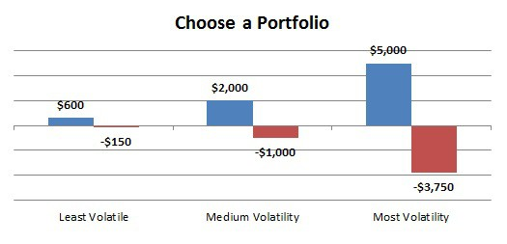

This question is pretty straight-forward. If you would feel comfortable risking the loss of nearly $4,000 for the chance to gain $5,000 then you are clearly able to tolerate more investment risk. If you would rather only risk a much smaller amount, and be comfortable if it meant only the possibility to earn lower return, then you are less risk tolerant. *(Score from one to three points)*

**8) What kind of stocks do you generally prefer?**

* High-growth companies making tech advances that could jump quickly
* Established companies with some potential for growth
* Mature companies that may not be headline news but pay stable dividends

This isn’t meant to pick stocks but to get a feel for the kind of investment in which you are comfortable. Shares of companies like Coca-Cola are not going to make you a millionaire overnight but the odds of losses are very low. Shares of that hot tech-startup could surge with a patent discovery but the company could also go bust, losing all your money. Which would you be comfortable putting your money in? *(Score from one to three points)*

**9) What type of bonds do you generally prefer?**

* High-yield bonds that offer high interest rates even if the company is less secure
* Tax-free bonds paying lower rates but backed by governments and cities

Even fixed-income bonds can be risky and attract a certain type of investor. Would you prefer the slow and steady of government-backed bonds, even if they don’t pay much, or do you need a little more risk even in your bond investments? *(Score from one to two points)*

**10) My current and future income sources are…**

* Uncertain, I work independently and income varies
* The industry in which I work is cyclical and layoffs are common
* Nothing is certain but I have good seniority and should not have to worry
* I have contracts in place that will nearly guarantee my employment or a strong severance

You need to balance your financial risk with your investment risk. Many that work in the financial markets, i.e. stock traders and advisors, have very little risk tolerance because their income is directly tied to the markets. A market collapse or recession may severely limit their income so they do not want to simultaneously suffer investment losses as well. On the other hand, tenured professors and others with contracted employment may be able to take a little more investment risk since their income is all but guaranteed. *(Score from one to four points)*

**What is my Investment Risk Tolerance?**

Adding up the points in the ten questions, you get a score between 10 and 34 points. You will find most investment risk tolerance calculators on the internet use some kind of a scoring methodology to place you within one of about five categories from very low tolerance to very high tolerance for risk.

With an idea of how much risk you can handle without causing much discomfort, you can start to look at different investments and proportions for your portfolio. No matter what risk category you are in, you always want some diversification across different investments like stocks, bonds and real estate but your own needs will determine how much in each.

The table below is not a hard-fast rule of how you should invest your money but a guide to consider your investment risk tolerance and different investment categories.

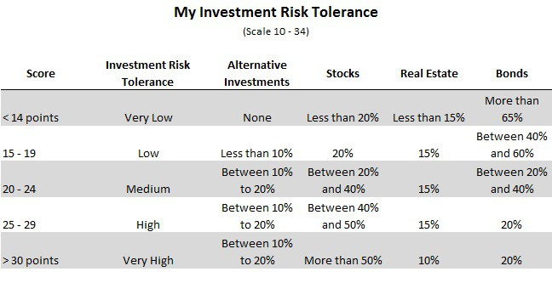

Investment Risk Tolerance Chart

Alternative assets are investments like private equity, venture capital and hedge funds, investments in start-up companies and other very high-risk ideas. You’ll probably not want any of these investments if you do not like risk or need your money quickly.

Stocks are generally riskier than bonds and real estate but provide an excellent return over a long period. With interest rates on many bonds paying next to nothing, even the most risk averse person may want to hold some stocks.

Real estate is generally a fairly safe investment with steady returns of both price and cash. Because of the trouble getting your money out quickly, I would limit real estate investment to less than 15% or 20% of your total wealth.

Bonds are generally the safest investments, though you can buy “junk” bonds that pay high rates but are very uncertain. They will provide a stable return through cash payments and do not involve much risk.

Beyond these four categories of investments, check out the investment risk tolerance pyramid below that does a good job of defining and outlining other options.

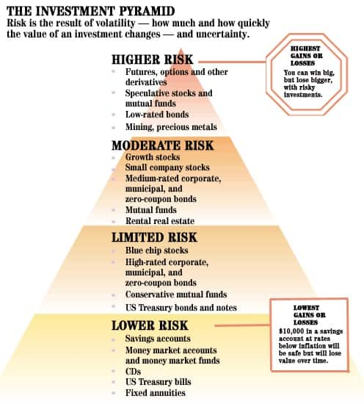

Investment Risk Tolerance Pyramid

Once you have an idea of your investment risk tolerance, you can start looking at other factors in your investor policy statement. We’ll cover the five most important factors in a post next week before moving on to figuring out your portfolio return and how to put investments together.